**Game of Thrones**

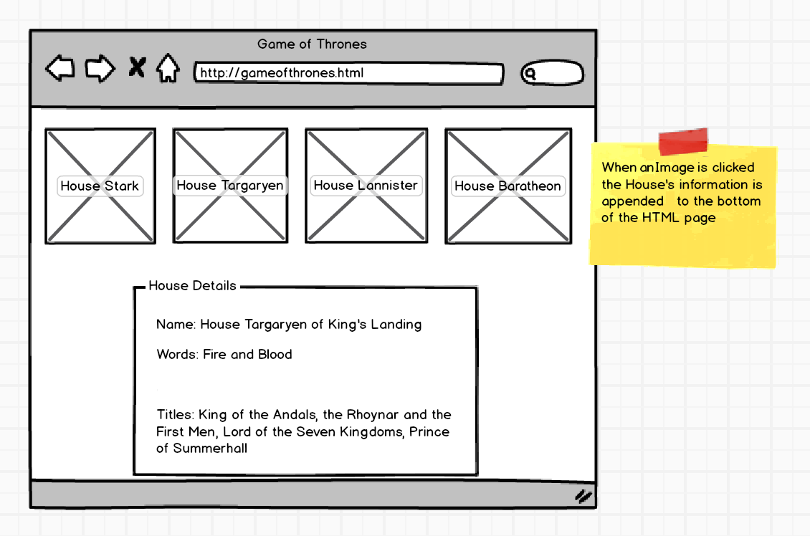

The Game of Thrones API is located here: [ASOIAF](https://anapioficeandfire.com/). Their documentation is great and will show how to use their API. Images you may use are found here: [Houses](http://s3.amazonaws.com/General_V88/boomyeah/company_209/chapter_3926/handouts/chapter3926_7250_gameofthrones.zip)

**Note: An API Key is not needed.**

When a User clicks an Image, the House Details should be appended or updated with the correct House information pulled from the API. For full names of the houses, you may check [this entry](https://www.quora.com/What-are-the-names-of-the-noble-houses-and-the-Seven-Kingdoms-of-Westeros).